Analytical Solutions for the Nonlinear Homogeneous Fractional Biological Equation using a Local Fractional Operator
¹ Department of Mathematics, College of Education for Pure Science, University of Thi-Qar, Thi-Qar, Iraq
² Department of Mathematics, Faculty of College of Education for Pure Science, University of Thi-Qar, Thi-Qar, Iraq
* Corresponding email: athmar.razaaq@utq.edu.iq
lkalzaki@utq.edu.iq
Abstract:
This study uses the Natural Variation decomposition technique, which is a great tool for solving fractional biological population equations. The fractional derivatives are described in terms of the Caputo's operator sense. A series of variation components that converge to the exact solution of the problem are used to describe the outcome of the suggested technique. Examples are provided to demonstrate how the suggested technique can be used.

Keywords: Caputo’s fractional derivative, Natural transform, Variation iteration method.

1-Introduction
Modern technology has radically changed the world and our way of life. Numerous engineering fields, such as fluid dynamics, aerodynamics, the sciences of the body, and finance, utilize technology. The modeling of mathematical objects has a profound impact on and shapes the design of technology. Differential equations may be used to represent the modeling in the form of a mathematical model.
Mathematical computations can be used to model many diseases, and data collection and careful analysis can be used to control them [11]. Using differential equations, biology and mathematics have a strong and fascinating connection. Fractional order differential equations (FDEs) are the name given to the non-integer order differential equations [1,8-10]. Fractional calculus is the area of mathematics concerned with FDEs [19].
The operators for fractional derivatives have been provided by numerous academics in great number. The fractional derivative operator by Caputo [12] is the most well-known. The fractional order integral operator was developed by Li et al. to handle differential equations [17]. Fractional order differential equations have recently been solved using a variety of transformations. Laplace, Sumudu, and Elzaki transforms are a few of them [4,5,6,7, 13,14,15,18].
In this work, we will deal with the natural transform iterative method (NTIM), a combination of the natural transform and the new iterative method which is variation iteration method (VIM).
$D_{ ζ}^{ γ}ν=\frac{∂^{2}ν^{2}}{∂l^{2}}+\frac{∂^{2}ν^{2}}{∂ϑ^{2}}+hν^{a} \left(1- rν^{b} \right)$ (1.1)
where$, ν$ = $ν$ ($l$, $ϑ$, $ζ$)is the population density and f are the supply of population due to births and deaths. The h and r are the real numbers and $f(l, ϑ)$ is the initial condition. The FBPM is a mathematical model of biology, and we are striving to present the $FNVIM$, a coupling method of the $FVIM$ and NT, and use it to resolve it. The remainder of this work consists of the portions listed below: In Section 2, there are some definitions for fractional calculus. The definition of a natural transform is covered in Section 3 in detail. Section 4 carries out the $FNVIM$ with CFO analysis. Examples of $FNVIM$ applications are shown in Section 5. In Section 6, there is a conclusion to the study.
2- Preliminaries
This section goes over several fractional calculus principles and symbols that will come in handy during this inquiry [2, 3, 16].
Definition 2.1. Suppose $ν\left(ζ\right)∈R , ζ>0$ , which is in the space $C_{m}, m ∈ R$ if there exists
$\{ ρ,\left(ρ>m\right),s.t.ν\left(ζ\right)=ζ^{ρ}ν_{1}\left(ζ\right), where ν_{1}\left(ζ\right)∈C[0,8) \}$
and $ν(ζ)$ is known as in the space $C_{m}^{n} when {ν }^{n}∈ C_{m}, m ∈N .$
Definition 2.2. The fractional integral operator of order $γ ≥ 0$ for Riemann Liouville of $ν\left(ζ\right)∈ C_{m},m≥-1$ is given by the form
$I^{γ} ν\left(ζ\right)=\{ \frac{1}{ Γ\left(γ\right)}\int_{0}^{ζ}{} {\left(ζ - ξ\right)}^{γ-1} ν\left(ξ\right) dξ, γ > 0, ζ > 0 I^{ 0}ν\left(ζ\right)= ν\left(ζ\right) , γ = 0$ (2.1)
where $Γ\left(·\right)$ is the recognizable Gamma function. The following are the characteristics of the operator $I^{γ} : For ν ∈ Cm, m ≥ -1, γ, σ ≥ 0, then$
$1. I^{γ}I^{σ} ν\left(ζ\right)= I^{γ+σ}ν\left(ζ\right)$
$2. I^{γ}I^{σ} ν\left(ζ\right) = I^{σ}I^{γ} ν\left(ζ\right)$
Definition 2.3. In the understanding of Caputo, $ν(ζ)$’s fractional derivative is as follows:
$D^{γ} ν\left(ζ\right)= I^{n-γ}D^{n} ν\left(ζ\right)= \frac{1}{ Γ\left(n - γ\right)} \int_{0}^{ζ}{} {\left(ζ - ξ\right)}^{n-γ-1} ν^{\left(n\right)}\left(ξ\right) dξ , \left(2.2\right)$
$such that n - 1 < γ ≤ n, n ∈ N, ζ > 0 and ν ∈ C_{-1}^{n}$
Definition 2.4. The following formula gives the Mittag-Leffler function $E_{γ}$ if it satisfies the
following:
$E_{γ}$ (z) = $\sum_{n=0}^{∞}{}\frac{Z^{γ}}{ Γ(nγ + 1)}$ , for each γ > 0 (2.3)
3- Natural Transform definition
We present some context for the natural transform approach [3] in this section.
Definition 3.1. The function $ν(ζ)$ for $ζ∈R$has a natural transform defined by
$N\left[ν\left(ζ\right)\right]= R\left(S, U\right)= \int_{-∞}^{∞}{}e^{-Sζ} ν\left(Uζ\right)dζ, S,U∈\left(-∞, ∞\right) \left(3.1\right)$
We denote that the Natural transform of the time function $ν(ζ)$ is$N[ν(ζ)]$, and the variables $η$ and $l$ are the Natural transform elements. Furthermore, define $ν(ζ)H(ζ)$ as on the axis of positive real, if $H(ζ)$ is Heaviside function, and$ζ ∈ (0, ∞)$. Consider
$A=\{ν(ζ):∃M, t_{1}, t_{2} >0, with |ν(ζ)|≤ {Me}^{\frac{ |ζ|}{tj}} , for ζ∈ {(-1)}^{j}×[0, ∞), j ∈Z^{+}\}$
The natural transform, often known as the NT, is defined as follows:
$N\left[ν\left(ζ\right)H\left(ζ\right)\right]=N^{+}\left[ν\left(ζ\right)\right]= R^{+} \left(S, U\right)=\int_{0}^{∞}{}e^{-Sζ} ν\left(Uζ\right)dζ , S,U ∈ (-∞, ∞) \left(3.2\right)$

4- Fractional Biological Population Equation ($FBPE$)
Let us consider a generalized non-linear Biological Iteration equation of the form:
$D_{ ζ}^{ γ}ν\left(l,ϑ,ζ\right)=\frac{∂^{2}ν^{2}}{∂l^{2}}+\frac{∂^{2}ν^{2}}{∂ϑ^{2}}+hν^{a} \left(1- rν^{b} \right)$(4.1)
with the initial condition:
$ν(l, ϑ, 0) = f(l, ϑ)$ (4.2)
Applying NT to each side of (4.1), and by using the differential property of FNVIM, we have
$N\left[D_{ ζ}^{ γ}ν\left(l,ϑ,ζ\right)\right]=N\left[\frac{∂^{2}ν^{2}}{∂l^{2}}+\frac{∂^{2}ν^{2}}{∂ϑ^{2}}+hν^{a} \left(1- rν^{b} \right)\right]$
$\frac{S^{γ}}{U^{γ }}ν\left(l,ϑ,ζ\right)-\frac{ S^{γ-1 }}{U^{γ }} ν\left(l, ϑ, 0\right)=N\left[\frac{∂^{2}ν^{2}}{∂l^{2}}+\frac{∂^{2}ν^{2}}{∂ϑ^{2}}+hν^{a} \left(1- rν^{b} \right)\right]$ (4.3)
$ν_{n+1}\left(l,ϑ,ζ\right)={ ν}_{n}+λ\left(ξ\right)\left[\frac{S^{γ}}{U^{γ }}ν_{n}-\frac{ S^{γ-1 }}{U^{γ }} ν\left(l, ϑ, 0\right)-N\left[\frac{∂^{2}{ν_{n}}^{2}}{∂l^{2}}+\frac{∂^{2}{ν_{n}}^{2}}{∂ϑ^{2}}+h{ν_{n}}^{a} \left(1- r{ν_{n}}^{b} \right)\right]\right]$
Take the variation
$δ\left[ν_{n+1}\right]=δ\left[ν_{n}\right]+λ\left(ξ\right)δ\left[\frac{S^{γ}}{U^{γ }}ν_{n}-\frac{ S^{γ-1 }}{U^{γ }} ν\left(l, ϑ, 0\right)-N\left[\frac{∂^{2}{ν_{n}}^{2}}{∂l^{2}}+\frac{∂^{2}{ν_{n}}^{2}}{∂ϑ^{2}}+h{ν_{n}}^{a} \left(1- r{ν_{n}}^{b} \right)\right]\right]$ (4.4)
$δ\left[ν_{n}\right]\left[1+λ\left(ξ\right)\frac{S^{γ}}{U^{γ }}\right]=0$
$λ\left(ξ\right)=\frac{-U^{γ }}{S^{γ}}$ (4.5)
$ν_{n+1}\left(l,ϑ,ζ\right)={ ν}_{n}-\frac{ U^{γ }}{S^{γ}}\left[\frac{S^{γ}}{U^{γ }}ν_{n}-\frac{ S^{γ-1 }}{U^{γ }} ν\left(l, ϑ, 0\right)-N\left[\frac{∂^{2}{ν_{n}}^{2}}{∂l^{2}}+\frac{∂^{2}{ν_{n}}^{2}}{∂ϑ^{2}}+h{ν_{n}}^{a} \left(1- r{ν_{n}}^{b} \right)\right]\right]$ (4.6)
By applying Natural inverse to (4.6)
$ν_{n+1}\left(l,ϑ,ζ\right)=N^{-1} \left[ \frac{ 1 }{ S }ν\left(l, ϑ, 0\right)+\frac{{ U}^{γ}}{{ S}^{γ }} N \left[\frac{∂^{2}{ν_{n}}^{2}}{∂l^{2}}+\frac{∂^{2}{ν_{n}}^{2}}{∂ϑ^{2}}+h{ν_{n}}^{a} \left(1- r{ν_{n}}^{b} \right)\right]\right]$ (4.7)
$ν_{n+1}\left(l,ϑ,ζ\right)=ν\left(l, ϑ, 0\right)+N^{-1} \left[ \frac{{ U}^{γ}}{{ S}^{γ }} N \left[\frac{∂^{2}{ν_{n}}^{2}}{∂l^{2}}+\frac{∂^{2}{ν_{n}}^{2}}{∂ϑ^{2}}+h{ν_{n}}^{a} \left(1- r{ν_{n}}^{b} \right)\right]\right]$
Assume that
${ν_{n}}^{2}=\sum_{n=0}^{∞}{}A_{n}$ (4.8)
$ν_{n+1}\left(l,ϑ,ζ\right)=ν\left(l, ϑ, 0\right)+N^{-1} \left[ \frac{{ U}^{γ}}{{ S}^{γ }} N \left[\frac{∂^{2}A_{n }}{∂l^{2}}+\frac{∂^{2}A_{n} }{∂ϑ^{2}}+h{ν_{n}}^{a} \left(1- r{ν_{n}}^{b} \right)\right]\right]$ (4.9)
5- Applications
Example 5.1
Consider the nonlinear fractional biological Iteration equation is given as the following:
$D_{ζ}^{γ}ν\left(l,ϑ,ζ\right)-ν_{ll}^{2}-ν_{ϑϑ}^{2}-hν=0 (5.1)$
w.r.t initial condition
$ν\left(l,ϑ,ζ\right)=\sqrt{lϑ} (5.2)$
$N\left[D_{ζ}^{γ}ν\left(l,ϑ,ζ\right)\right]-N\left[ν_{ll}^{2}+ν_{ϑϑ}^{2}+hν\right]=0 (5.3)$
$\frac{S^{γ}}{U^{γ}}ν\left(l,ϑ,ζ\right)-\frac{S^{γ-1}}{U^{γ}}ν\left(l,ϑ,0\right)- N\left[\frac{∂^{2}ν^{2}}{{∂l}^{2}}+\frac{∂^{2}ν^{2}}{{∂ϑ}^{2}}+hν\right]=0$
$ν_{n+1}\left(l,ϑ,ζ\right)=ν_{n}\left(l,ϑ,ζ\right)+λ\left(ξ\right)\left[\frac{S^{γ}}{U^{γ}}ν_{n}-\frac{S^{γ-1}}{U^{γ}}ν\left(l,ϑ,0\right)- N\left[\frac{∂^{2}{ν_{n}}^{2}}{{∂l}^{2}}+\frac{∂^{2}{ν_{n}}^{2}}{{∂ϑ}^{2}}+hν_{n}\right]\right]$
By using (4.5), we get
$λν_{n+1}\left(l,ϑ,ζ\right)=ν_{n}\left(l,ϑ,ζ\right)-\frac{S^{γ}}{U^{γ}}\left[\frac{S^{γ}}{U^{γ}}ν_{n}-\frac{S^{γ-1}}{U^{γ}}ν\left(l,ϑ,0\right)- N\left[\frac{∂^{2}{ν_{n}}^{2}}{{∂l}^{2}}+\frac{∂^{2}{ν_{n}}^{2}}{{∂ϑ}^{2}}+hν_{n}\right]\right]$
Taking Natural inverse
$ν_{n+1}\left(l,ϑ,ζ\right)= ν\left(l,ϑ,0\right)+N^{-1}\left[\frac{S^{γ}}{U^{γ}} N\left[\frac{∂^{2}{ν_{n}}^{2}}{{∂l}^{2}}+\frac{∂^{2}{ν_{n}}^{2}}{{∂ϑ}^{2}}+hν_{n}\right]\right] (5.4)$
$ν_{n}^{2}=\sum_{n=0}^{∞}{}A_{n }$
$ν_{n+1}\left(l,ϑ,ζ\right)= ν\left(l,ϑ,0\right)+N^{-1}\left[\frac{S^{γ}}{U^{γ}} N\left[\frac{∂^{2}{A_{n}}^{ }}{{∂l}^{2}}+\frac{∂^{2}{A_{n}}^{ }}{{∂ϑ}^{2}}+hν_{n}\right]\right] (5.6)$
$ν_{0}=ν\left(l,ϑ,0\right)=\sqrt{lϑ}$
$ν_{1}=ν\left(l,ϑ,0\right)+N^{-1}\left[\frac{S^{γ}}{U^{γ}} N\left[\frac{∂^{2}{A_{0}}^{ }}{{∂l}^{2}}+\frac{∂^{2}{A_{0}}^{ }}{{∂ϑ}^{2}}+hν_{0}\right]\right] (5.7)$
$A_{0}=ν_{0}.ν_{0}=\sqrt{lϑ}.\sqrt{lϑ}=lϑ$
$\frac{∂^{2}{A_{0}}^{ }}{{∂l}^{2}}=0 ,\frac{∂^{2}{A_{0}}^{ }}{{∂ϑ}^{2}}=0$
$ν_{1}=\sqrt{lϑ}+N^{-1}\left[\frac{S^{γ}}{U^{γ}}N\left[0+0+h\sqrt{lϑ} \right] \right]$
$= \sqrt{lϑ}+\frac{ζ^{γ}}{Γ(γ+1)} h\sqrt{lϑ} (5.8)$
$ν_{2}=ν\left(l,ϑ,0\right)+N^{-1}\left[\frac{S^{γ}}{U^{γ}} N\left[\frac{∂^{2}{A_{1}}^{ }}{{∂l}^{2}}+\frac{∂^{2}{A_{1}}^{ }}{{∂ϑ}^{2}}+hν_{1}\right]\right] (5.9)$
$A_{1}=ν_{0}.ν_{1}+ν_{1}.ν_{0}$
$=\sqrt{lϑ} .\left[\sqrt{lϑ}+\frac{ζ^{γ}}{Γ\left(γ+1\right)} h\sqrt{lϑ} \right]+\left[\sqrt{lϑ}+\frac{ζ^{γ}}{Γ\left(γ+1\right)} h\sqrt{lϑ} \right]. \sqrt{lϑ}$
$=2\left(1+\frac{ζ^{γ}}{Γ\left(γ+1\right)} h\right) lϑ (2.10)$
$\frac{∂^{2}{A_{1}}^{ }}{{∂l}^{2}}=0 , \frac{∂^{2}{A_{1}}^{ }}{{∂ϑ}^{2}}=0$
$ν_{2}=\sqrt{lϑ}+N^{-1}\left[\frac{U^{γ}}{S^{γ}} N\left[0+0+h\sqrt{lϑ}+\frac{ζ^{γ}}{Γ\left(γ+1\right)} h^{2}\sqrt{lϑ}\right]\right]$
$= \sqrt{lϑ}+\frac{ζ^{γ}}{Γ\left(γ+1\right)} h\sqrt{lϑ}+ \frac{ζ^{2γ}}{Γ\left(2γ+1\right)} h^{2}\sqrt{lϑ}$
$∶$
$ν_{n}=\sqrt{lϑ}+\frac{ζ^{γ}}{Γ\left(γ+1\right)} h\sqrt{lϑ}+ \frac{ζ^{2γ}}{Γ\left(2γ+1\right)} h^{2}\sqrt{lϑ}+…+\frac{ζ^{nγ}}{Γ\left(nγ+1\right)} h^{n}\sqrt{lϑ}$
$ν\left(l,ϑ,ζ\right)=ν_{n}= \sqrt{lϑ}[1+\frac{ζ^{γ}}{Γ\left(γ+1\right)} h+\frac{ζ^{2γ}}{Γ\left(2γ+1\right)} h^{2}+…+\frac{ζ^{nγ}}{Γ\left(nγ+1\right)} h^{n}$
$=E_{γ}\left(hζ^{γ}\right)\sqrt{lϑ} (2.11)$
When $γ=1$
$ν\left(l,ϑ,ζ\right)=\sqrt{lϑ} [1+ hζ+\frac{h^{2}ζ^{2}}{2!}+…]$
$=e^{hζ}\sqrt{lϑ} \left(5.12\right)$
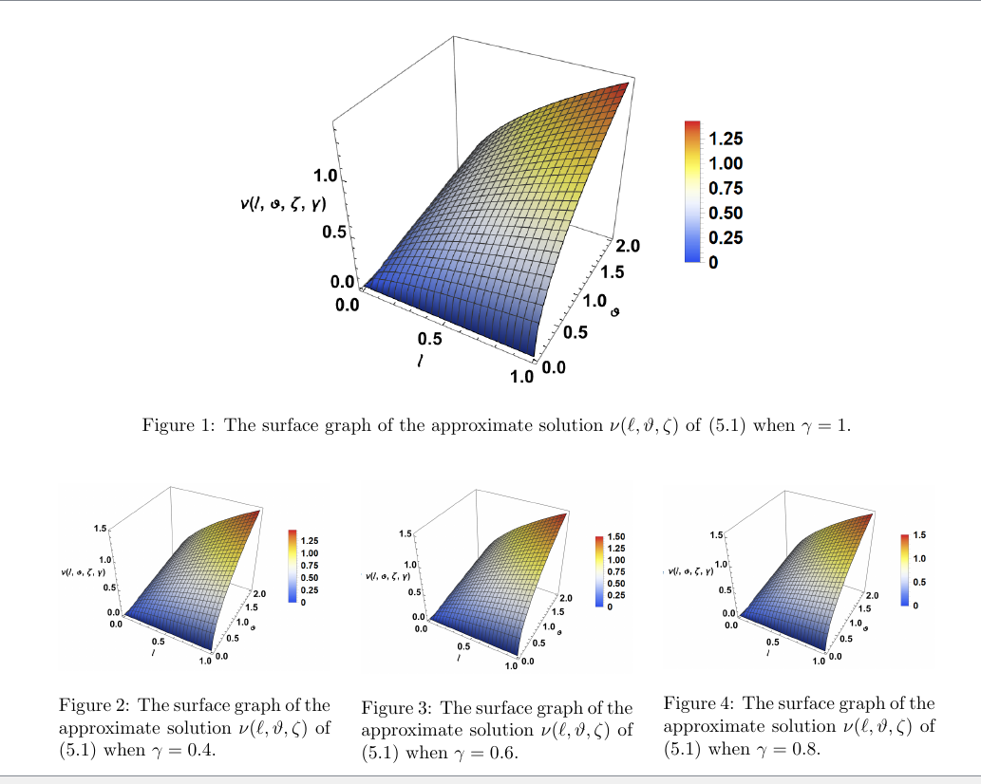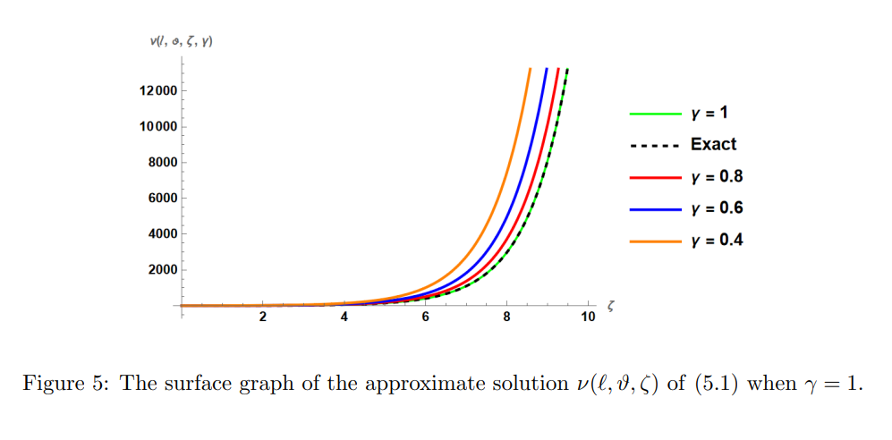
Example 5.2
Consider the nonlinear fractional biological population is given as the following:
$D_{ζ}^{γ}ν\left(l,ϑ,ζ\right)-ν_{ll}^{2}-ν_{ϑϑ}^{2}-ν=0 (5.13)$
w.r.t initial condition
$ν\left(l,ϑ,0\right)=\sqrt{sinsin (l) sinhsinh (ϑ) } (5.14)$
$N\left[D_{ζ}^{γ}ν\left(l,ϑ,ζ\right)\right]-N\left[ν_{ll}^{2}-ν_{ϑϑ}^{2}-ν\right]=0 (5.15)$
$\frac{S^{γ}}{U^{γ}}ν-\frac{S^{γ-1}}{U^{γ}}ν\left(l,ϑ,0\right)-N\left[\frac{∂^{2}ν^{2}}{{∂l}^{2}}+\frac{∂^{2}ν^{2}}{{∂ϑ}^{2}}+ν\right]=0 (5.16)$
$ν_{n+1}\left(l,ϑ,ζ\right)=ν_{n}\left(l,ϑ,ζ\right)+λ\left(ξ\right)[\frac{S^{γ}}{U^{γ}}ν_{n}-\frac{S^{γ-1}}{U^{γ}} ν\left(l,ϑ,0\right)- N\left[\frac{∂^{2}{ν_{n}}^{2}}{{∂l}^{2}}+\frac{∂^{2}{ν_{n}}^{2}}{{∂ϑ}^{2}}+ν_{n}\right]$
By using (4.5), we get
$ν_{n+1}\left(l,ϑ,ζ\right)=ν_{n}\left(l,ϑ,ζ\right)-\frac{U^{γ}}{S^{γ}}\left[\frac{S^{γ}}{U^{γ}}ν_{n}-\frac{S^{γ-1}}{U^{γ}} ν\left(l,ϑ,0\right)- N\left[\frac{∂^{2}{ν_{n}}^{2}}{{∂l}^{2}}+\frac{∂^{2}{ν_{n}}^{2}}{{∂ϑ}^{2}}+ν_{n}\right]\right]$
Taking Natural inverse
$ν_{n+1}\left(l,ϑ,ζ\right)=ν\left(l,ϑ,0\right)+N^{-1}\left[\frac{U^{γ}}{S^{γ}} N\left[\frac{∂^{2}{ν_{n}}^{2}}{{∂l}^{2}}+\frac{∂^{2}{ν_{n}}^{2}}{{∂ϑ}^{2}}+ν_{n}\right]\right] (5.17)$
$ν_{n}^{2}=\sum_{n=0}^{∞}{}A_{n}$
$ν_{n+1}\left(l,ϑ,ζ\right)=ν\left(l,ϑ,0\right)+N^{-1}\left[\frac{U^{γ}}{S^{γ}}N\left[\frac{∂^{2}A_{n}}{{∂l}^{2}}+\frac{∂^{2}A_{n}}{{∂ϑ}^{2}}+ν_{n}\right]\right] (5.18)$
$ν_{0}=ν\left(l,ϑ,0\right)=\sqrt{sinsin (l) sinhsinh (ϑ) } (5.19)$
$ν_{1}=ν\left(l,ϑ,0\right)+N^{-1}\left[\frac{U^{γ}}{S^{γ}}N\left[\frac{∂^{2}A_{0}}{{∂l}^{2}}+\frac{∂^{2}A_{0}}{{∂ϑ}^{2}}+ν_{0}\right]\right] (5.20)$
$A_{0}=ν_{0}.ν_{0}=\left(\sqrt{sinsin \left(l\right) sinhsinh \left(ϑ\right) }\right).\left(\sqrt{sinsin \left(l\right) sinhsinh \left(ϑ\right) }\right)=sinsin \left(l\right) sinhsinh \left(ϑ\right)$
$\frac{∂^{2}A_{0}}{{∂l}^{2}}= -sinsin \left(l\right) sinhsinh \left(ϑ\right)$
$\frac{∂^{2}A_{0}}{{∂ϑ}^{2}}=sinsin \left(l\right) sinhsinh \left(ϑ\right)$
$ν_{1}=\sqrt{sinsin \left(l\right) sinhsinh \left(ϑ\right) }+N^{-1}\left[\frac{U^{γ}}{S^{γ}}N\left[-sinsin \left(l\right) sinhsinh \left(ϑ\right) +sinsin \left(l\right) sinhsinh \left(ϑ\right) +\sqrt{sinsin \left(l\right) sinhsinh \left(ϑ\right) }\right]\right]$
$=\left(1+\frac{ζ^{γ}}{Γ\left(γ+1\right)}\right)\sqrt{sinsin \left(l\right) sinhsinh \left(ϑ\right) } (5.21)$
$ν_{2}=ν\left(l,ϑ,0\right)+N^{-1}\left[\frac{U^{γ}}{S^{γ}}N\left[\frac{∂^{2}A_{1}}{{∂l}^{2}}+\frac{∂^{2}A_{1}}{{∂ϑ}^{2}}+ν_{1}\right]\right] (5.22)$
$A_{1}=ν_{0}.ν_{1}+ν_{1}.ν_{0 }$
$=\sqrt{sinsin \left(l\right) sinhsinh \left(ϑ\right) }.\left[ \left(1+\frac{ζ^{γ}}{Γ\left(γ+1\right)}\right)\sqrt{sinsin \left(l\right) sinhsinh \left(ϑ\right) }\right]$
$+\left[\left(1+\frac{ζ^{γ}}{Γ\left(γ+1\right)}\right)\sqrt{sinsin \left(l\right) sinhsinh \left(ϑ\right) } \right].\sqrt{sinsin \left(l\right) sinhsinh \left(ϑ\right) }$
$=\left(1+\frac{ζ^{γ}}{Γ\left(γ+1\right)}\right)sinsin \left(l\right) sinhsinh \left(ϑ\right) +\left(1+\frac{ζ^{γ}}{Γ\left(γ+1\right)}\right)sinsin \left(l\right) sinhsinh \left(ϑ\right)$
$=2\left(1+\frac{ζ^{γ}}{Γ\left(γ+1\right)}\right)sinsin \left(l\right) sinhsinh \left(ϑ\right)$
$\frac{∂^{2}A_{1}}{{∂l}^{2}}=-2\left(1+\frac{ζ^{γ}}{Γ\left(γ+1\right)}\right)sinsin \left(l\right) sinhsinh \left(ϑ\right) (5.23)$
$\frac{∂^{2}A_{1}}{{∂ϑ}^{2}}=2\left(1+\frac{ζ^{γ}}{Γ\left(γ+1\right)}\right)sinsin \left(l\right) sinhsinh \left(ϑ\right)$
$ν_{2}=\sqrt{sinsin \left(l\right) sinhsinh \left(ϑ\right) }+N^{-1}[\frac{U^{γ}}{S^{γ}}N[-2\left(1+\frac{ζ^{γ}}{Γ\left(γ+1\right)}\right)sinsin \left(l\right) sinhsinh \left(ϑ\right) +$
$2\left(1+\frac{ζ^{γ}}{Γ\left(γ+1\right)}\right)sinsin \left(l\right) sinhsinh \left(ϑ\right)+\left(1+\frac{ζ^{γ}}{Γ\left(γ+1\right)}\right)\sqrt{sinsin \left(l\right) sinhsinh \left(ϑ\right) }] ]$
$=\sqrt{sinsin \left(l\right) sinhsinh \left(ϑ\right) }+\frac{ζ^{γ}}{Γ\left(γ+1\right)} \sqrt{sinsin \left(l\right) sinhsinh \left(ϑ\right) }+\frac{ζ^{2γ}}{Γ\left(2γ+1\right)}\sqrt{sinsin \left(l\right) sinhsinh \left(ϑ\right) }$
$∶$
$ν_{n}=\frac{ζ^{nγ}}{Γ\left(nγ+1\right)} \sqrt{sinsin \left(l\right) sinhsinh \left(ϑ\right) } (5.24)$
$ν\left(l,ϑ,ζ^{ }\right)=ν_{n}= \sqrt{sinsin \left(l\right) sinhsinh \left(ϑ\right) }\left[1+\frac{ζ^{γ}}{Γ\left(γ+1\right)}+…\frac{ζ^{nγ}}{Γ\left(nγ+1\right)}\right]$
$=E_{γ}\left(ζ^{γ}\right)\sqrt{sinsin \left(l\right) sinhsinh \left(ϑ\right) } (5.25)$
When$γ=1$
$ν\left(l,ϑ,ζ^{ }\right)=e^{ζ}\sqrt{sinsin \left(l\right) sinhsinh \left(ϑ\right) } (5.26)$

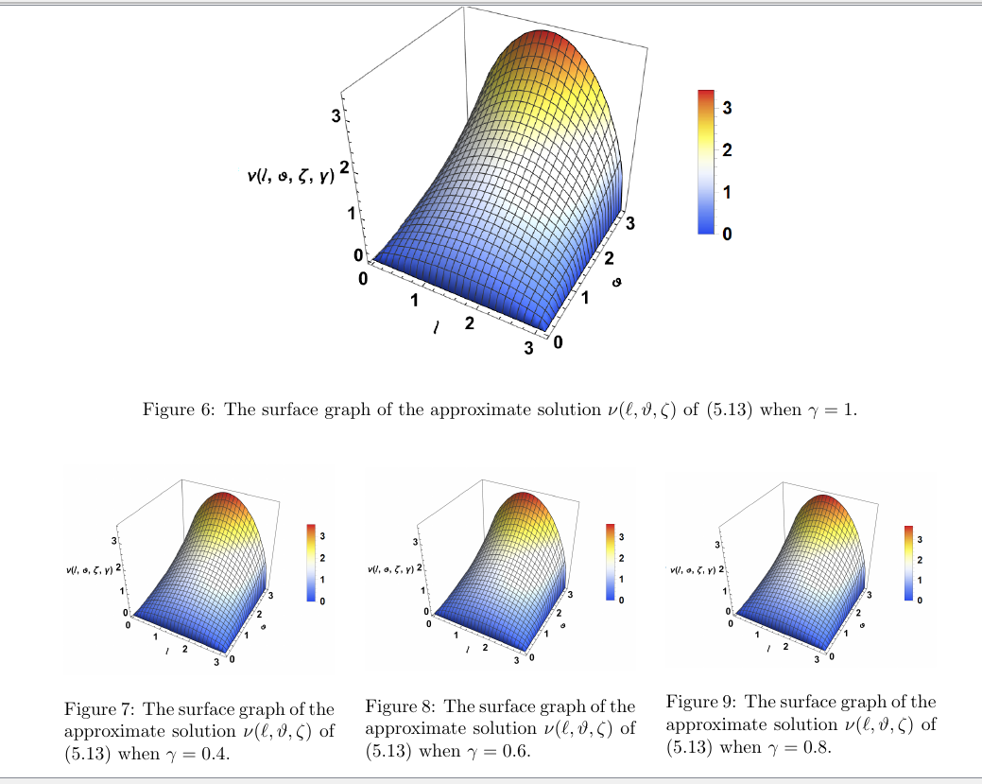
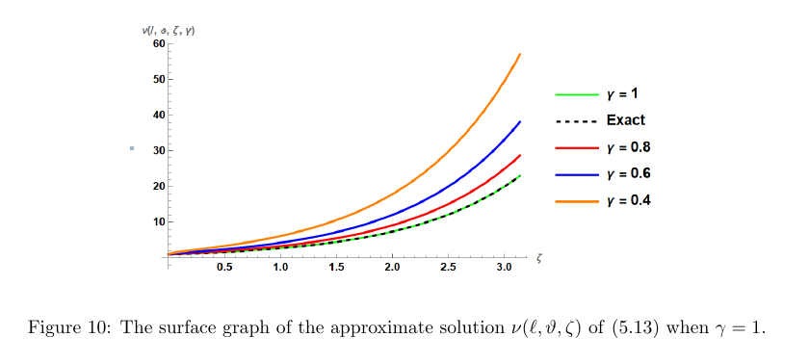
Example 5.3
Consider the nonlinear fractional biological population equation is given as the following

$D_{ ζ}^{ γ}ν\left(l,ϑ,ζ\right)- {ν^{2}}_{ll }- {ν^{2}}_{ϑϑ }+ν\left(\frac{ 8 }{9}ν+1\right)=0$ $(5.27)$
w.r.t initial condition
$ν\left(l, ϑ, 0\right)=e^{\frac{1}{ 3}(l + ϑ)}$ $(5.28)$
$N\left[D_{ ζ}^{ γ}ν\left(l,ϑ,ζ\right)\right]-N\left[ {ν^{2}}_{ll }+ {ν^{2}}_{ϑϑ }-ν\left(\frac{ 8 }{9}ν+1\right)\right]=0$ $(5.29)$

$\frac{S^{γ}}{U^{γ }}ν\left(l,ϑ,ζ\right)-\frac{ S^{γ-1 }}{U^{γ }} ν\left(l, ϑ, 0\right)-N\left[\frac{∂^{2}ν^{2}}{∂l^{2}}+\frac{∂^{2}ν^{2}}{∂ϑ^{2}}-ν\left(\frac{ 8 }{9}ν+1\right)\right]=0$
$ν_{n+1}\left(l,ϑ,ζ\right)={ ν}_{n}+λ\left(ξ\right)\left[\frac{S^{γ}}{U^{γ }}ν_{n}-\frac{ S^{γ-1 }}{U^{γ }} ν\left(l, ϑ, 0\right)-N\left[\frac{∂^{2}{ν_{n}}^{2}}{∂l^{2}}+\frac{∂^{2}{ν_{n}}^{2}}{∂ϑ^{2}}-ν_{n}\left(\frac{ 8 }{9}ν_{n}+1\right)\right]\right]$
$λ\left(ξ\right)=\frac{-U^{γ }}{S^{γ}}$ $(5.30)$
$ν_{n+1}\left(l,ϑ,ζ\right)={ ν}_{n}-\frac{ U^{γ }}{S^{γ}}\left[\frac{S^{γ}}{U^{γ }}ν_{n}-\frac{ S^{γ-1 }}{U^{γ }} ν\left(l, ϑ, 0\right)-N\left[\frac{∂^{2}{ν_{n}}^{2}}{∂l^{2}}+\frac{∂^{2}{ν_{n}}^{2}}{∂ϑ^{2}}-ν_{n}\left(\frac{ 8 }{9}ν_{n}+1\right)\right]\right]$
Taking Natural inverse
$ν_{n+1}\left(l,ϑ,ζ\right)= ν\left(l, ϑ, 0\right)+N^{-1}\left[\frac{ U^{γ }}{S^{γ}}N\left[\frac{∂^{2}{ν_{n}}^{2}}{∂l^{2}}+\frac{∂^{2}{ν_{n}}^{2}}{∂ϑ^{2}}-ν_{n}\left(\frac{ 8 }{9}ν_{n}+1\right)\right]\right]$
$ν_{n+1}\left(l,ϑ,ζ\right)= ν\left(l, ϑ, 0\right)+N^{-1}\left[\frac{ U^{γ }}{S^{γ}}N\left[\frac{∂^{2}{ν_{n}}^{2}}{∂l^{2}}+\frac{∂^{2}{ν_{n}}^{2}}{∂ϑ^{2}}-\frac{ 8 }{9}{ν_{n}}^{2}-ν_{n}\right]\right]$ $(5.31)$
${ν_{n}}^{2}=\sum_{n=0}^{∞}{}A_{n}$
$ν_{n+1}\left(l,ϑ,ζ\right)= ν\left(l, ϑ, 0\right)+N^{-1}\left[\frac{ U^{γ }}{S^{γ}}N\left[\frac{∂^{2}A_{n} }{∂l^{2}}+\frac{∂^{2}A_{n} }{∂ϑ^{2}}-\frac{ 8 }{9}A_{n}-ν_{n}\right]\right](5.32)$
$ν_{0}= ν\left(l, ϑ, 0\right)=e^{\frac{1}{ 3}(l + ϑ)}$ $(5.33)$
$ν_{1}\left(l,ϑ,ζ\right)= ν\left(l, ϑ, 0\right)+N^{-1}\left[\frac{ U^{γ }}{S^{γ}}N\left[\frac{∂^{2}A_{0} }{∂l^{2}}+\frac{∂^{2}A_{0} }{∂ϑ^{2}}-\frac{ 8 }{9}A_{0}-ν_{0}\right]\right]$ $(5.34)$
$A_{0}=ν_{0}.ν_{0}=\left(e^{\frac{1}{ 3}\left(l + ϑ\right)}\right).\left(e^{\frac{1}{ 3}\left(l + ϑ\right)}\right)$
=$\frac{ 4 }{ 9 }e^{\frac{ 2}{ 3}\left(l + ϑ\right)}$
$\frac{∂^{2}A_{0} }{∂l^{2}}$=$\frac{ 4 }{ 9 }e^{\frac{ 2}{ 3}\left(l + ϑ\right)}$ , $\frac{∂^{2}A_{0} }{∂ϑ^{2}}$=$\frac{ 4 }{ 9 }e^{\frac{ 2}{ 3}\left(l + ϑ\right)}$
$ν_{1}=e^{\frac{1}{ 3}\left(l + ϑ\right)}+N^{-1}\left[\frac{ U^{γ }}{S^{γ}}N\left[\frac{ 4 }{ 9 }e^{\frac{ 2}{ 3}\left(l + ϑ\right)}+\frac{ 4 }{ 9 }e^{\frac{ 2}{ 3}\left(l + ϑ\right)}-\frac{ 8 }{9}e^{\frac{ 2}{ 3}\left(l + ϑ\right)}-e^{\frac{1}{ 3}\left(l + ϑ\right)}\right]\right]$ $(5.35)$
$=\left(1-\frac{ζ^{γ}}{Γ\left(γ+1\right)}\right)e^{\frac{1}{ 3}\left(l + ϑ\right)}$
$ν_{2}\left(l,ϑ,ζ\right)= ν\left(l, ϑ, 0\right)+N^{-1}\left[\frac{ U^{γ }}{S^{γ}}N\left[\frac{∂^{2}A_{1 } }{∂l^{2}}+\frac{∂^{2}A_{1 } }{∂ϑ^{2}}-\frac{ 8 }{9}A_{1}-ν_{1}\right]\right]$ $(5.36)$
$A_{1}=ν_{0}.ν_{1}+ν_{1}.ν_{0}$
=${ e}^{\frac{1}{ 3}\left(l + ϑ\right)}.\left[\left(1-\frac{ζ^{γ}}{Γ\left(γ+1\right)}\right)e^{\frac{1}{ 3}\left(l + ϑ\right)}\right] +\left[\left(1-\frac{ζ^{γ}}{Γ\left(γ+1\right)}\right)e^{\frac{1}{ 3}\left(l + ϑ\right)}\right].e^{\frac{1}{ 3}\left(l + ϑ\right)}$
=$\left(1-\frac{ζ^{γ}}{Γ\left(γ+1\right)}\right)e^{\frac{ 2}{ 3}\left(l + ϑ\right)}$+$\left(1-\frac{ζ^{γ}}{Γ\left(γ+1\right)}\right)e^{\frac{ 2}{ 3}\left(l + ϑ\right)}$
=$2\left(1-\frac{ζ^{γ}}{Γ\left(γ+1\right)}\right)e^{\frac{ 2}{ 3}\left(l + ϑ\right)}$
$\frac{∂^{2}A_{1 } }{∂l^{2}}=\frac{ 8 }{9}\left(1-\frac{ζ^{γ}}{Γ\left(γ+1\right)}\right)e^{\frac{ 2}{ 3}\left(l + ϑ\right)}$ , $\frac{∂^{2}A_{1 } }{∂ϑ^{2}}=\frac{ 8 }{9}\left(1-\frac{ζ^{γ}}{Γ\left(γ+1\right)}\right)e^{\frac{ 2}{ 3}\left(l + ϑ\right)}$
$ν_{2}= e^{\frac{1}{ 3}\left(l + ϑ\right)}+N^{-1}\left[\frac{ U^{γ }}{S^{γ}}N\left[\frac{ 8 }{9}\left(1-\frac{ζ^{γ}}{Γ\left(γ+1\right)}\right)e^{\frac{ 2}{ 3}\left(l + ϑ\right)}+\frac{ 8 }{9}\left(1-\frac{ζ^{γ}}{Γ\left(γ+1\right)}\right)e^{\frac{ 2}{ 3}\left(l + ϑ\right)}-\frac{ 16 }{9}\left(1-\frac{ζ^{γ}}{Γ\left(γ+1\right)}\right)e^{\frac{ 2}{ 3}\left(l + ϑ\right)}-e^{\frac{1}{ 3}\left(l + ϑ\right)}+\frac{ζ^{γ}}{Γ\left(γ+1\right)}e^{\frac{1}{ 3}\left(l + ϑ\right)}\right]\right]$
$= e^{\frac{1}{ 3}\left(l + ϑ\right)}-\frac{ζ^{γ}}{Γ\left(γ+1\right)}e^{\frac{1}{ 3}\left(l + ϑ\right)}+\frac{ζ^{2γ}}{Γ\left(2γ+1\right)}e^{\frac{1}{ 3}\left(l + ϑ\right)}$
$∶$
$ν_{n}={(-1)}^{n}\frac{ζ^{nγ}}{Γ\left(nγ+1\right)}e^{\frac{1}{ 3}\left(l + ϑ\right)}$ $(5.37)$
$ν\left(l,ϑ,ζ^{ }\right)=ν_{n}= e^{\frac{1}{ 3}\left(l + ϑ\right)}\left[1-\frac{ζ^{γ}}{Γ\left(γ+1\right)}+…\frac{ζ^{nγ}}{Γ\left(nγ+1\right)}\right]$
$=E_{γ}\left(-ζ^{γ}\right)e^{\frac{1}{ 3}\left(l + ϑ\right)}$ $(5.38)$
When$γ=1$
$ν\left(l,ϑ,ζ\right)=e^{\frac{1}{ 3}\left(l + ϑ\right)} [1- ζ+\frac{ζ^{2}}{2!}-…]$
$ν\left(l,ϑ,ζ\right)=e^{\frac{1}{ 3}\left(l + ϑ\right)- ζ} (5.39)$
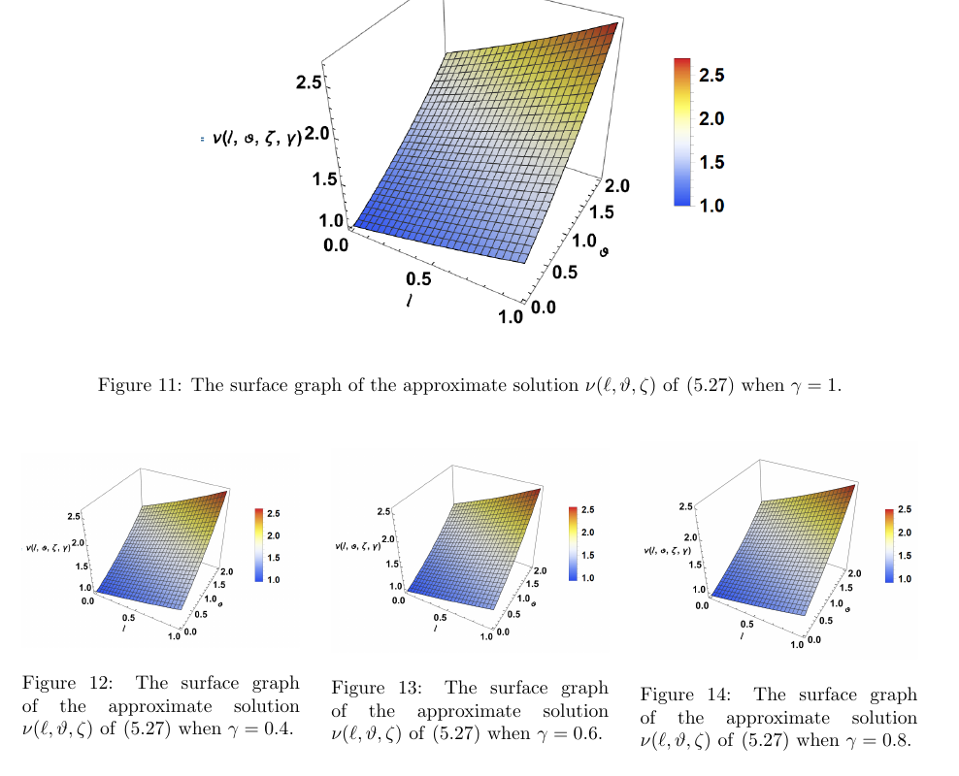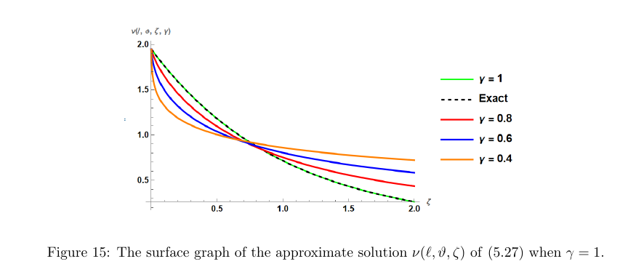
6- Conclusion
Using the NVIM, we examined the time-fractional biological equation’s approximate solution. Because of the minimal number of computations, the suggested method’s technique is determined to be more dependable than other analytical methods. Because it comprises of applying the NT directly to the provided issue and then applying the VIM, the approach is easily understood by the readers. As a result, the proposed approach is regarded to be a useful analytical tool for solving fractional PDEs.
REFERENCES
- Ali, Q. Iqbal, J. K. K. Asamoah, and S. Islam, "Mathematical modeling for the transmission potential of Zika virus with optimal control strategies", The European Physical Journal Plus, vol. 137, no. 1, pp. 1–30, 2022.
- L.K. Alzaki, H.K. Jassim” Time-Fractional Differential Equations with an Approximate
Solution”, J. Niger. Soc. Phys. Sci., 4(3), (2022) 818. https://doi.org/10.46481/jnsps.2022.818
- K. Alzaki, H. K. Jassim, "The approximate analytical solutions of nonlinear fractional ordinary equations", International Journal of Nonlinear Analysis and Applications, 12(2) (2021) 527-535.
- Jamshed, N. A. A. M. Nasir, S. S. P. M. Isa et al., "Thermal growth in solar water pump using Prandtl–Eyring hybrid nanofluid: a solar energy application", Scientific Reports, vol. 11, no. 1, pp. 1–21, 2021.
- W. Jamshed, K. S. Nisar, R. W. Ibrahim, F. Shahzad, and M. R. Eid, “Thermal expansion optimization in solar aircraft using tangent hyperbolic hybrid nanofluid: a solar thermal application,” Journal of Materials Research and Technology, vol. 14, pp. 985–1006, 2021.
- W. Jamshed, S. U. Devi, and K. S. Nisar, “Single phase-based study of ag-cu/EO Williamson hybrid nanofluid flow over a stretching surface with shape factor,” Physica Scripta, vol. 96, no. 6, article 065202, 2021.
- Jamshed, K. S. Nisar, R. W. Ibrahim, F. Shahzad, and M. R. Eid, "Thermal expansion optimization in solar aircraft using tangent hyperbolic hybrid nanofluid: a solar thermal application", Journal of Materials Research and Technology, vol. 14, pp. 985–1006, 2021.
- H. Zhang, A. Ali, M. A. Khan, M. Y. Alshahrani, T. Muhammad, and S. Islam, "Mathematical analysis of the TB model with treatment via Caputo-type fractional derivative", Discrete Dynamics in Nature and Society 2021, vol. 2021, pp. 1–15, 2021.
- Ali, F. S. Alshammari, S. Islam, M. A. Khan, and S. Ullah, "Modeling and analysis of the dynamics of novel coronavirus (COVID-19) with Caputo fractional derivative", Results in Physics, vol. 20, article 103669, 2021.Journal of Nanomaterials 11

- M. Chu, A. Ali, M. A. Khan, S. Islam, and S. Ullah, Dynamics of fractional order COVID-19 model with a case study of Saudi Arabia, Results in Physics, vol. 21, article 103787, 2021.

- Baleanu, H. Mohammadi, and S. Rezapour, "A mathematical theoretical study of a particular system of Caputo–Fabrizio fractional differential equations for the Rubella disease model", Advances in Difference Equations, vol. 2020, no. 1, 2020.
- N. H. Tuan, H. Mohammadi, and S. Rezapour, “A mathematical model for COVID-19 transmission by using the Caputo fractional derivative,” Chaos, Solitons & Fractals, vol. 140, article 110107, 2020.
- Singh, V. Gill, S. Kundu, and D. Kumar, "On the Elzaki transform and its applications in fractional free electron laser equation", Acta Universitatis Sapientiae, Mathematica, vol. 11, no. 2, pp. 419–429, 2019.
- S. Bodkhe and S. K. Panchal, "On Sumudu transform of fractional derivatives and its applications to fractional differential equations", Asian Journal of Mathematics and Computer Research, vol. 11, no. 1, pp. 69–77, 2016.
- Daftardar-Gejji, H. Jafari, "An iterative method for solving nonlinear functional equations", J. Math.Anal. Appl 316 (2006) 753–763.
- M. Jafari, "Iterative Methods for Solving System of Fractional Differential Equations", Ph.D. Thesis, Pune University, 2006.
- C. Li, D. Qian, and Y. Chen, “On Riemann-Liouville and Caputo derivatives,” Discrete Dynamics in Nature and Society, vol. 2011, 15 pages, 2011.
- Kexue and P. Jigen, "Laplace transform and fractional differential equations", Applied Mathematics Letters, vol. 24, no. 12, pp. 2019–2023, 2011
- Hilfer, Applications of Fractional Calculus in Physics, World scientific, Covent Garden, London, 2000.

